1. Write a command to check our windows version.

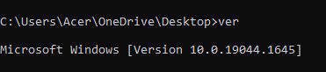

1. Show the current date of your system using the command.



1. Create the directory date. Within that directory create a text file to show the current system date.

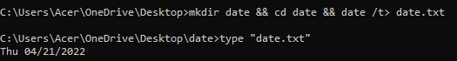

1. Show the system information using the command.

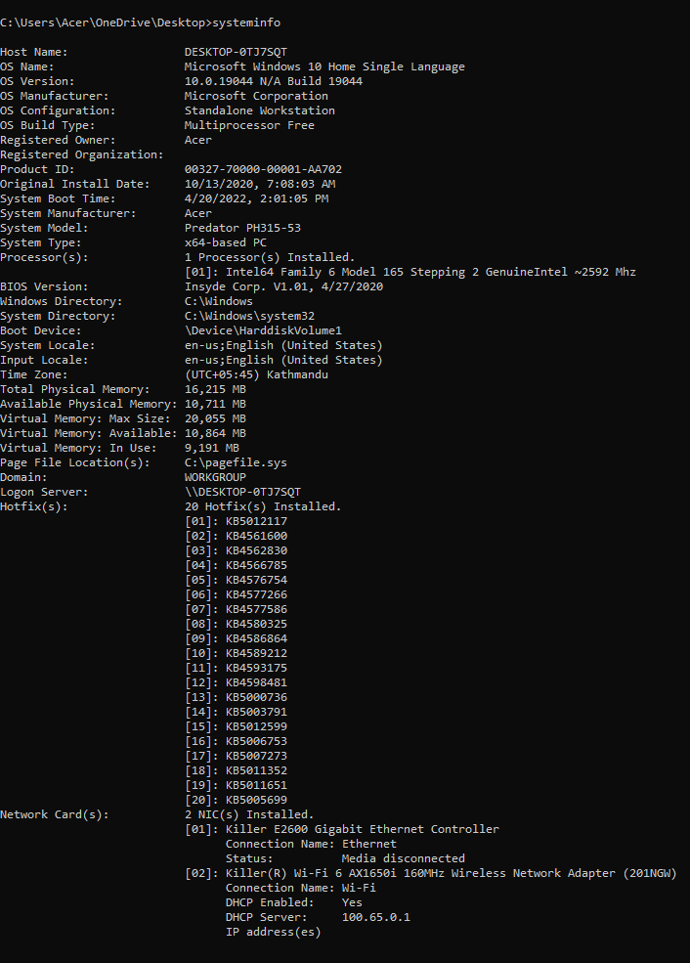

1. Create the directory called **systemInfo** and create the file name **systemInfo.txt**. In that file all your system information should be auto generated using the command.

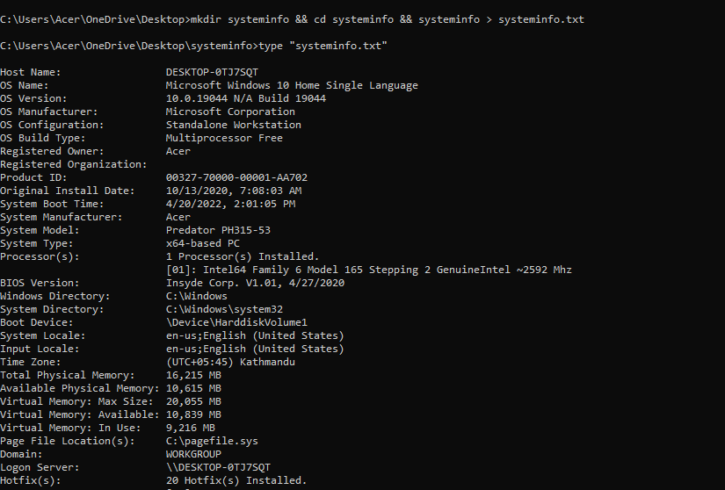

1. Launch the **systeminfo.txt** using notepad using the command.

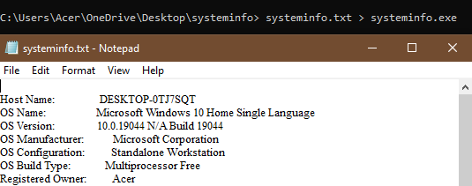

1. Briefly explain about the Ping, getmac, ipconfig, powercfg command.

**ping:** The ping command is a Command Prompt command that is used to see if a source computer can communicate with a specific destination computer.

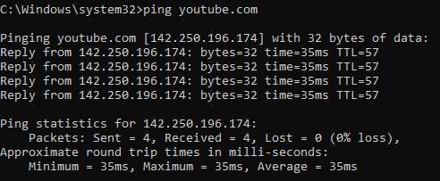

**getmac:** The getmac is a Windows command that displays the Media Access Control (MAC) addresses for all of the computer's network adapters.

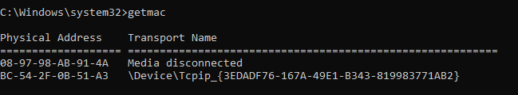

**ipconfig:** (Configuration of the Internet Protocol) The IP address assigned to the system is shown and managed using this command line utility.

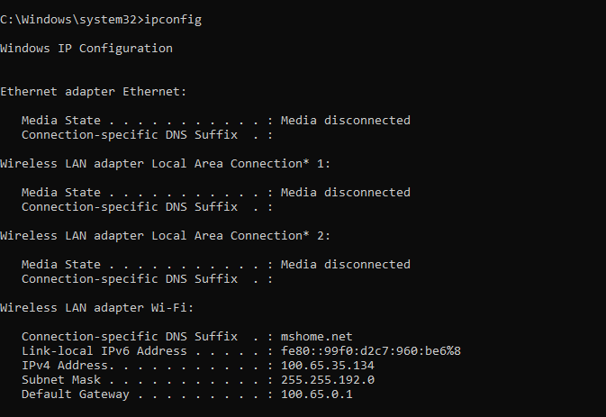

**powercfg:** Powercfg.exe is a command-line application that lets you control all customisable power system settings, including hardware-specific options not available through the Control Panel.

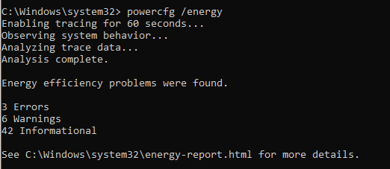

1. Ping the google domain and paste the screenshot.

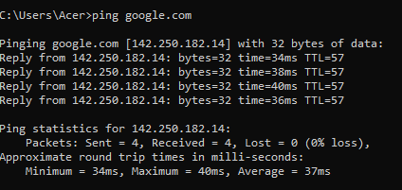

1. Show the Ip address of your device.

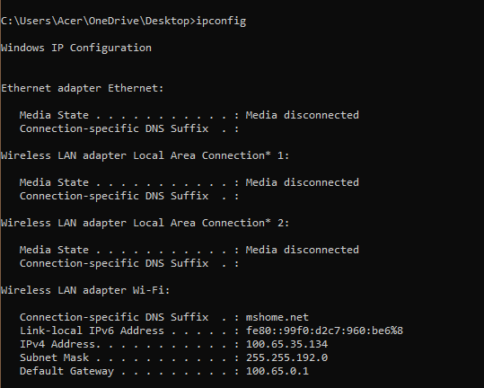

1. What is the use of the FC command?

FC, or file comparison, is a command-line tool for comparing the contents of text or files. It supports both ASCII and Unicode text.

1. Create the directory called difference. In that directory create two files File1.txt and File2.txt. Add contents in 2 files and perform the ascii comparison of these 2 files.

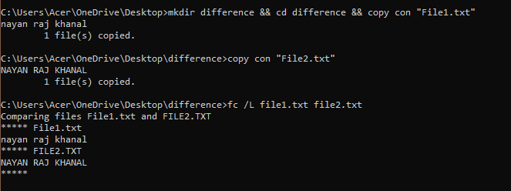

1. Generate the power efficiency diagnostics report using the command.



1. What does the CHKDSK do?

CHKDSK checks the file system of a volume for logical and physical errors. If used without parameters, chkdsk displays only the status of the volume and does not fix any errors. If used with the /f, /r, /x, or /b parameters, it fixes errors on the volume.

1. Use the command in no.13 to check your disk space and repair any problem if it exists

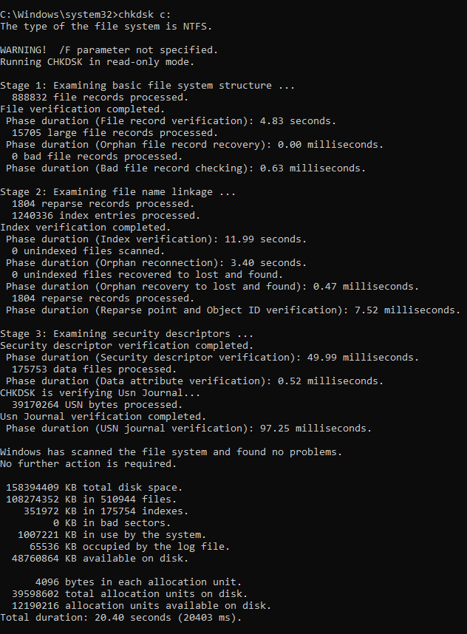

1. Explain doskey /history command.

*Doskey/History* is one of the two examples of a command called Doskey, other being *doskey*. *Doskey/History* recalls previously entered command-line commands, edits command lines, and creates macros.

